You can use the Apple Push Notification Service to propagate information from the backend to the device. In this tutorial you use the native iOS push services to enable APNS for your iOS app. To enable your app for push notifications, you need to carry out the following tasks:

* Create an App ID (automated)
* Create provisioning profile (automated)
* Create CSR (Certificate Signing Request) file
* Create a CER file
* Install the CER file and create a p12 file
* Update your application to use Push Notifications
* Configure APNS in SAP Cloud Platform cockpit

In order to implement Push Notifications, a paid Apple developer account is required. Students or other developers with a personal Apple ID for their team will not be able to use push notifications, because they won’t have access to the Developer Portal to generate the required certificate.

Step 1: Use Xcode to create an App ID and Provisioning Profile

The App ID is used to identify your app and ensures the Apple Push Notification Servers will properly send push notifications to your app. The Provisioning Profile will be used to sign your app later on.

With the help of Xcode we don’t have to do much manually to create those two things.Open up your Product Sample App project in Xcode.

We make sure everything is set up correctly. First let’s see if the project is configured correctly. Click on the xcodeproj file to open the project configuration of your app. Make sure you are on the **General** tab.

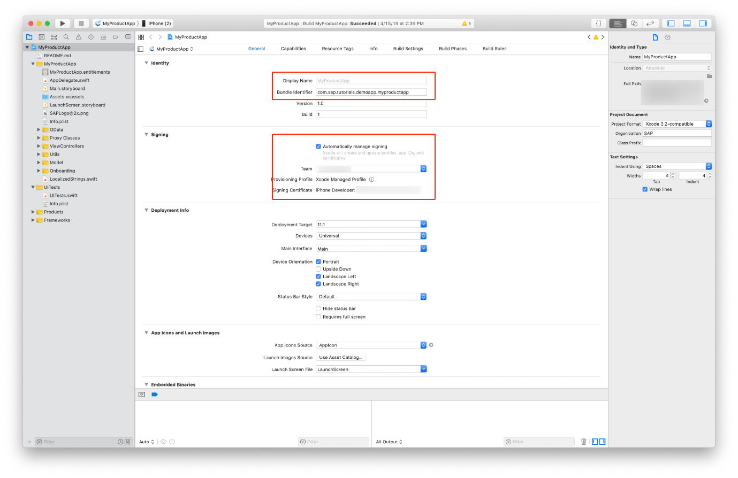

Make sure your **Bundle Identifier** is correct in the **Identify** section. Check if **Automatically manage signing** is activated and you chose the correct **Signing Certificate** in the **Signing** section.

Next we make sure the app uses the Push Notification capability. For that click on the **Capabilities** tab and enable **Push Notifications**. If two grey check marks appear in the section then the enablement was successful.

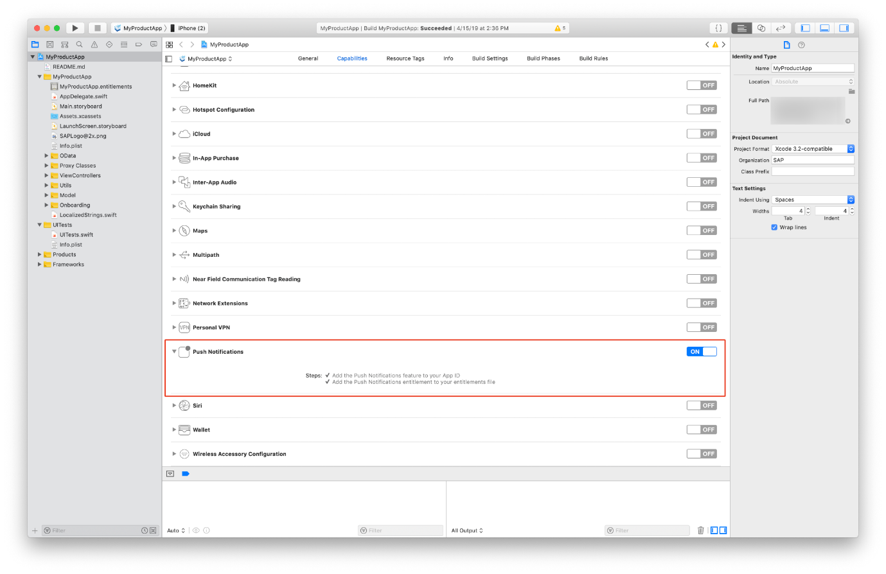

Our App Project is now configured.

Step 2: Create the Certificate Signing Request file

In order to use the **Apple Push Notification service**, we need to create a **CSR file**.

On your Mac, open the **Keychain Access** application, and navigate to **Keychain Access > Certificate Assistant > Request a Certificate From a Certificate Authority…**

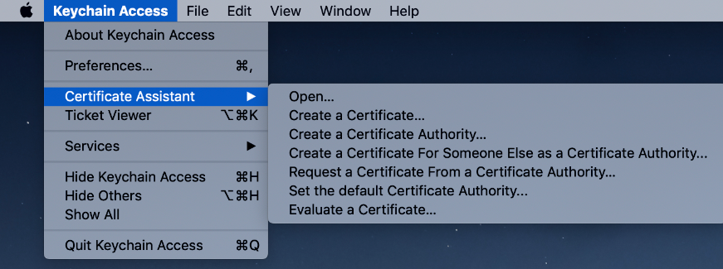

In the dialog, enter the email address which is associated with your Apple Developer account. Also, make sure you check the **Request is saved to disk** and the **Let me specify key pair information** option.

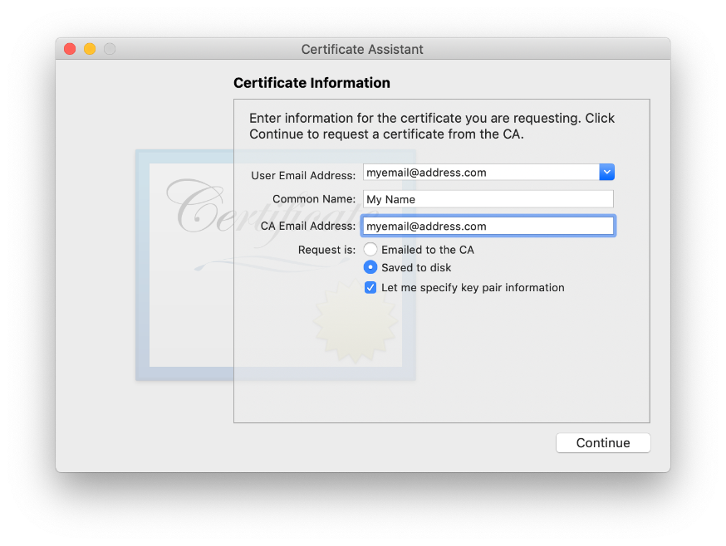

Click **Continue**.

Choose a folder to store the certificate – it is good practice to store generated files in a separate folder for each project – and click **Save**.

Once you see a dialog saying the certificate is saved successfully, click **Done** to finish.

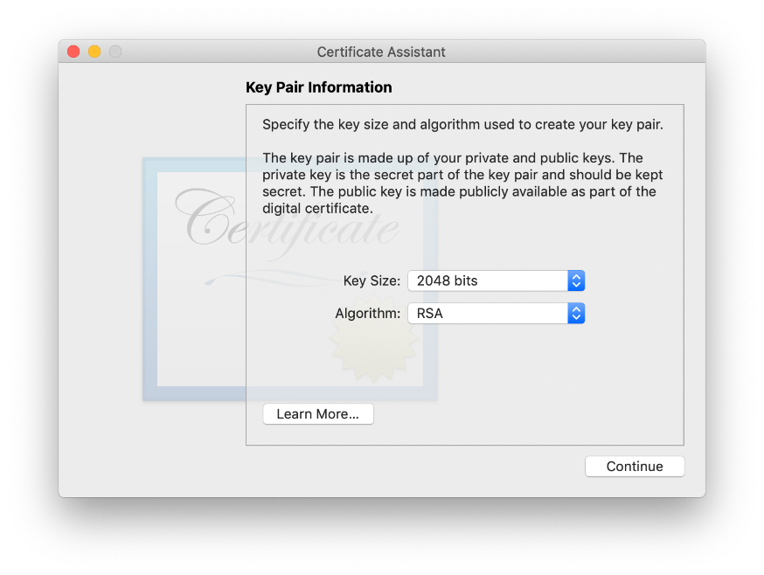

The certificate is now saved to you hard drive and added to your Keychain as well as a public and private.

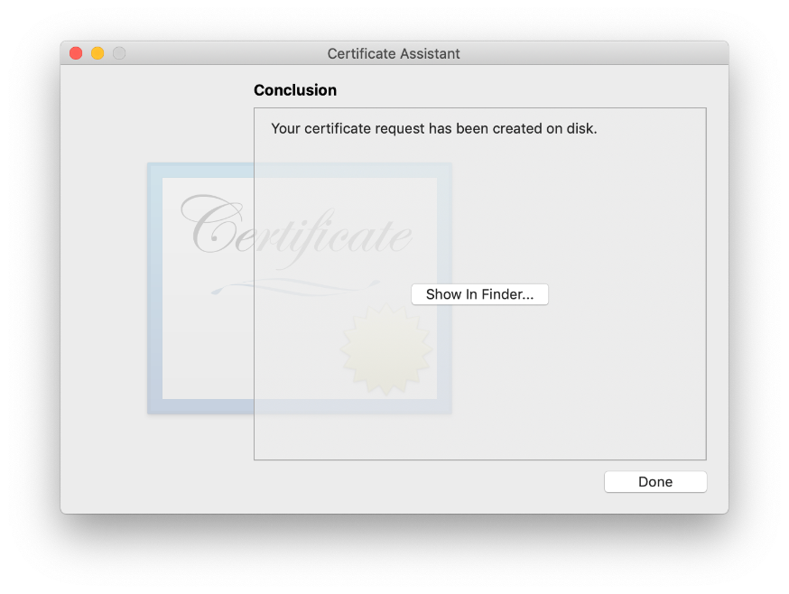

Step 3: Create .CER file in your Apple Developer Account

Go to your [Apple Developer Account](https://developer.apple.com/) and click on **Certificates, Identifiers & Profiles**.

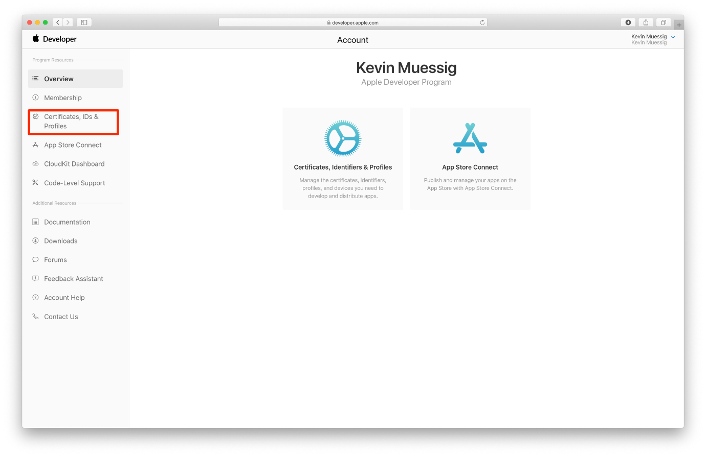

From there click on **Identifiers** to get the list of all your apps.

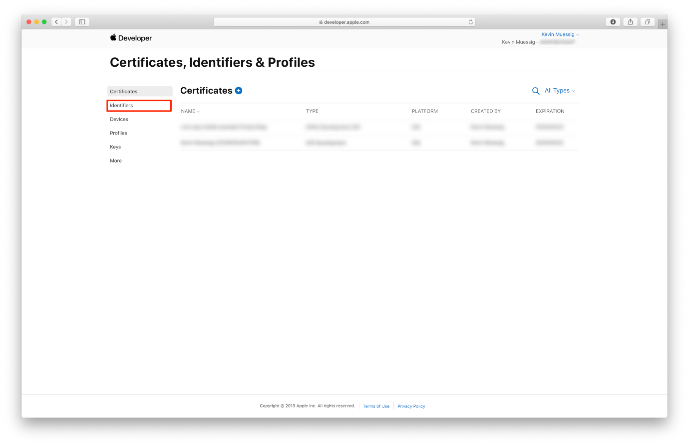

Now locate the com.sap.mobile.example.ProductApp. Click on it to see the details.

If by any chance you’ve used a different App name or/and bundle identifier, select that one in the list.

If in any case you can’t see your app listed here please go ahead and follow the creation process of an App ID with the **Plus** icon. Make sure the app name and identifier are the same as your Xcode project.

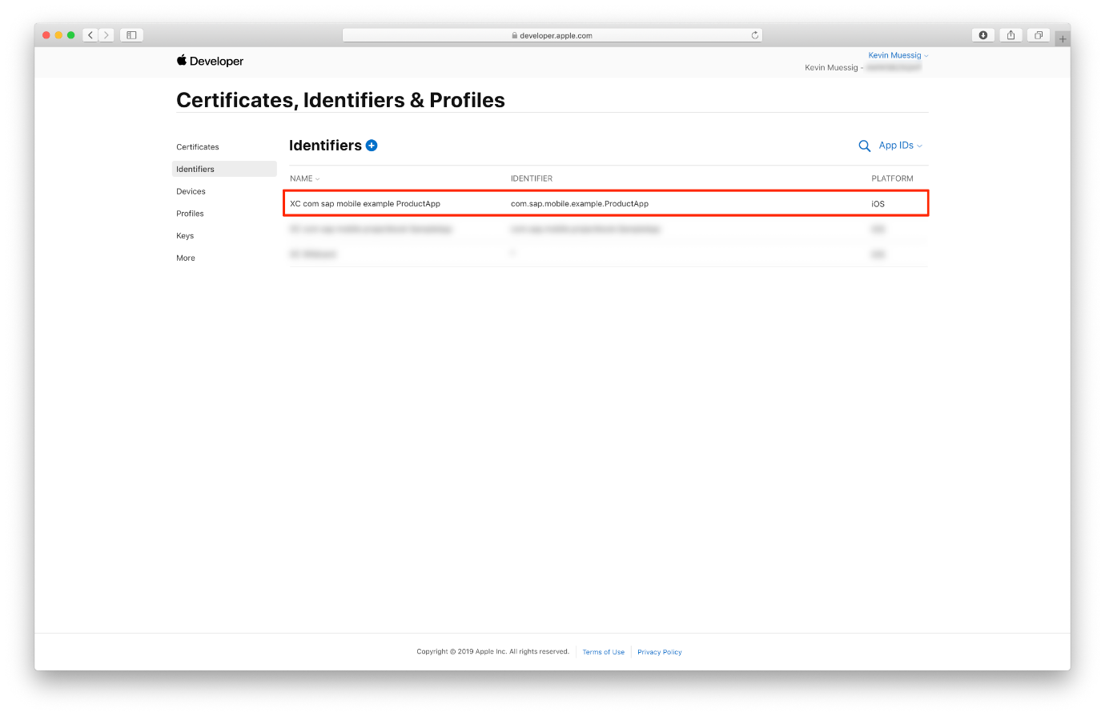

In the upcoming detail screen please scroll down until you see the **Push Notifications** shows up in the list.

You can see Xcode also made sure that **Push Notifications** are enabled for your app. Now you have to configure this app feature. Click on **Configure**.

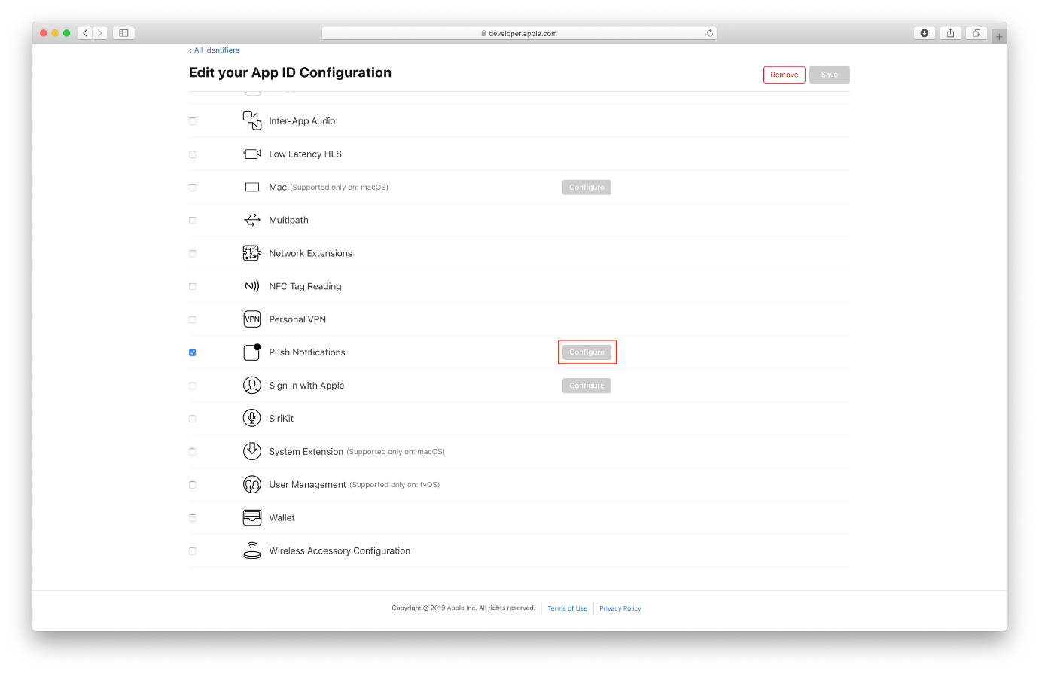

Click on **Create Certificate** to start the workflow for creating the needed .CER file.

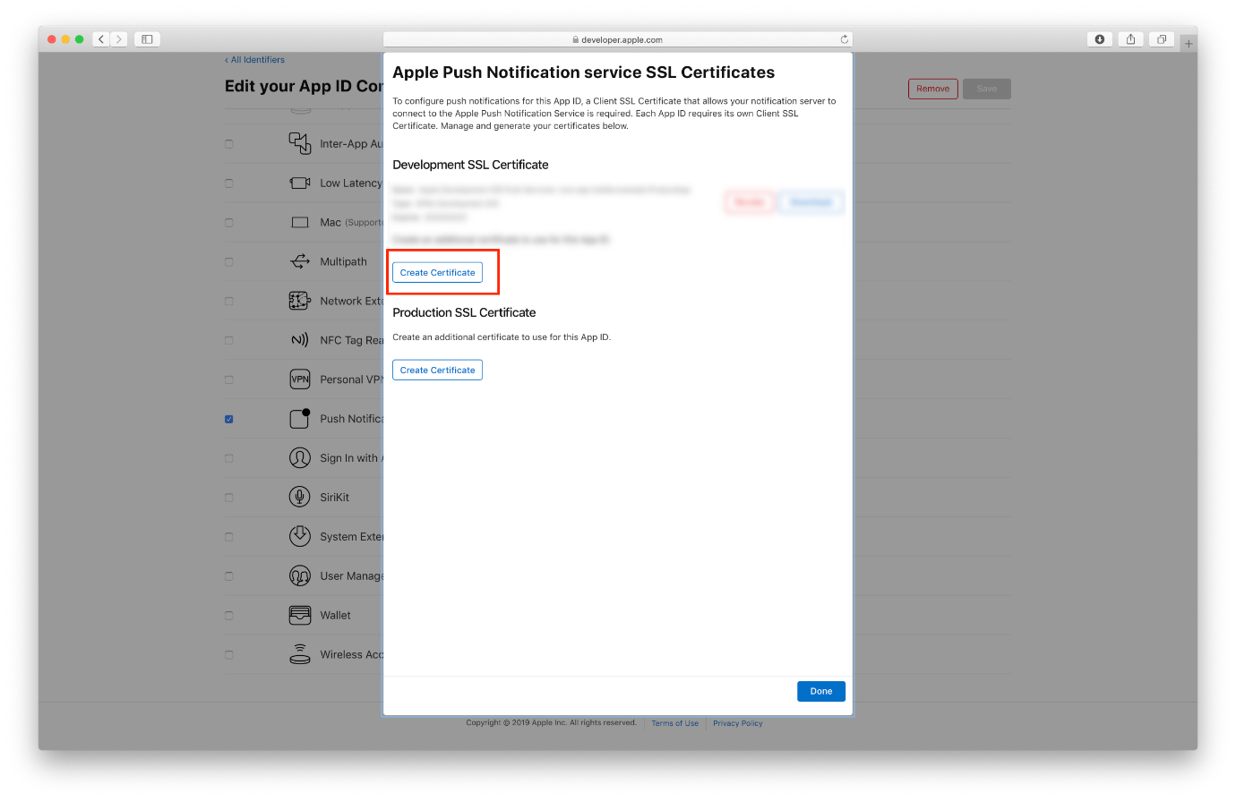

The workflow asks you to upload the previously created CSR file. Please click on **Choose File** and upload the file. To download your CER please click on **Continue**.

Apple will now create a .CER file for you which is issued by the **Apple Worldwide Developer Relations Certification Authority**.

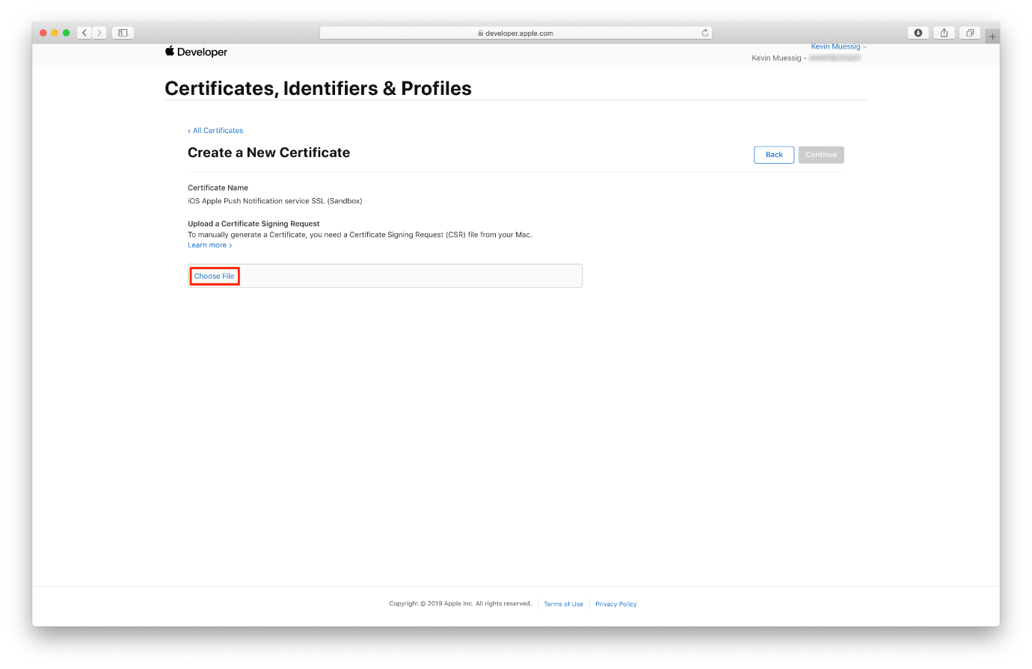

Click on the **Download** button to download your certificate.

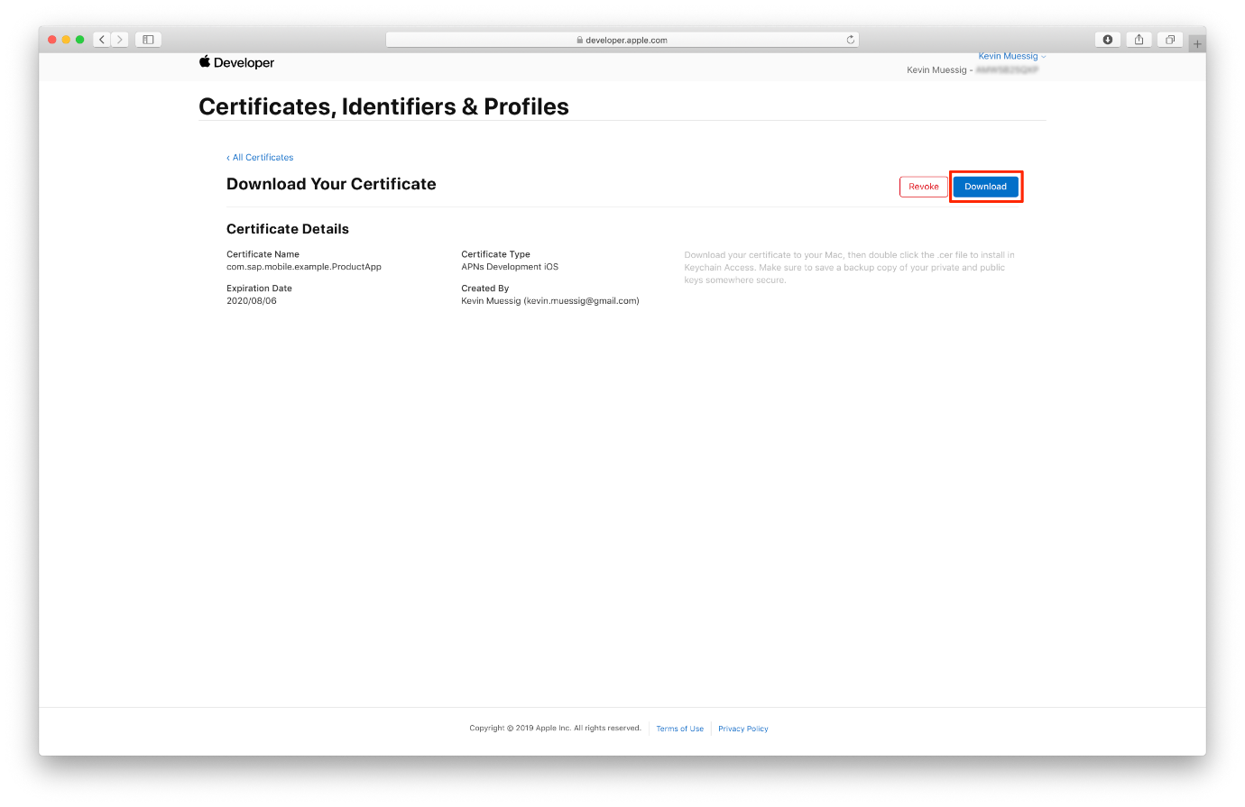

If you go back to the certificates list of your app, you should see the just created certificate listed.

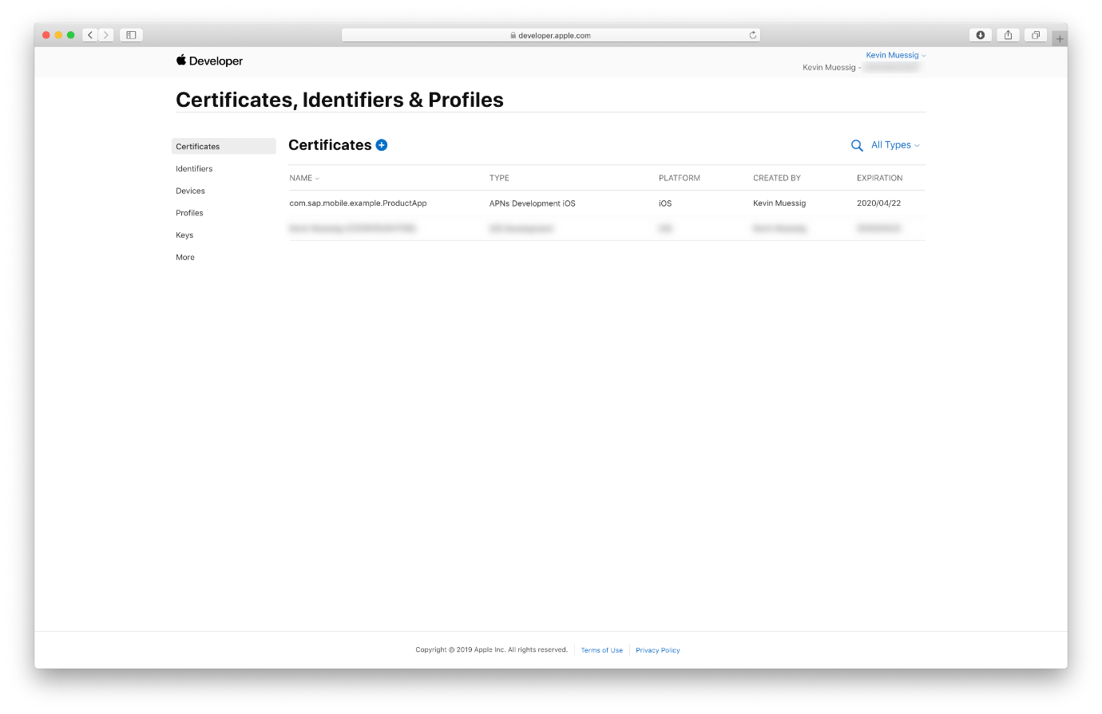

Step 4: Install the .CER file and create the .p12 file

In order to configure the APNS on **SAP Cloud Platform Mobile Services** we need to install the .CER file and create the needed .p12 file.

A .p12 file is a encrypted container for the certificate and private key. This file is needed by Mobile Services for the APNS configuration.

Locate your downloaded .CER file and double click on it in order to install the certificate.

In case the **Add Certificate** dialog pops up make sure to choose **Login** from the dropdown and click on **Add**.

If the certificate is added correctly to the Keychain you should see it in the MyCertificates section, make sure you selected **login** as keychain.

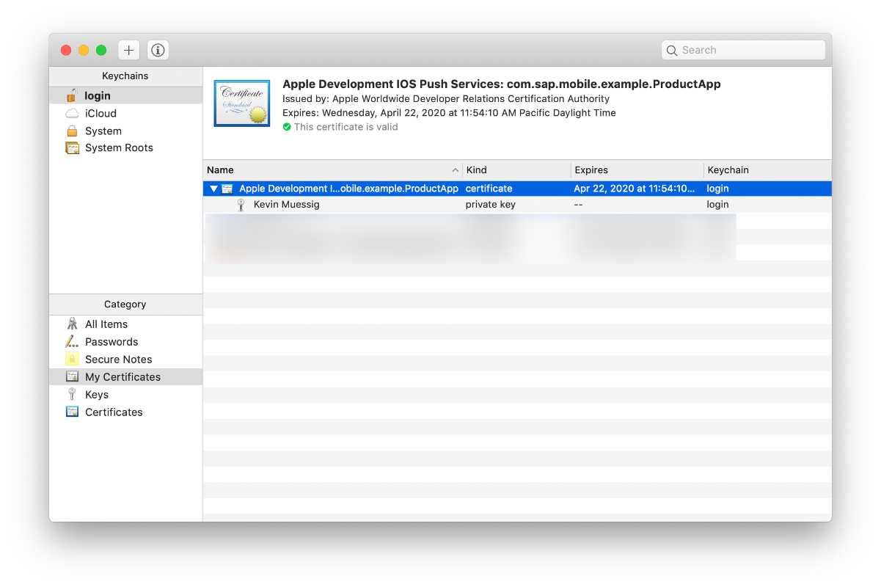

Select the certificate as well as the private key and right-click to export those two items.

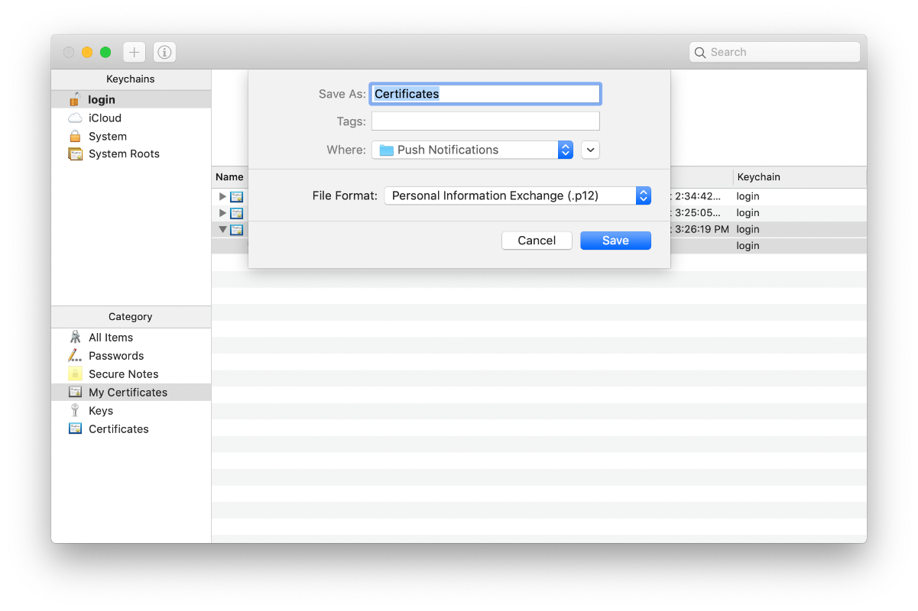

Make sure that in the dropdown **Personal Information Exchange (.p12)** is selected and click on **Save**. You will be prompted to enter a password, click on **OK** to export the files.

While you have the option to leave the password empty, you must provide a password when configuring the certificate for use with SAP Cloud Platform mobile service for development and operations.

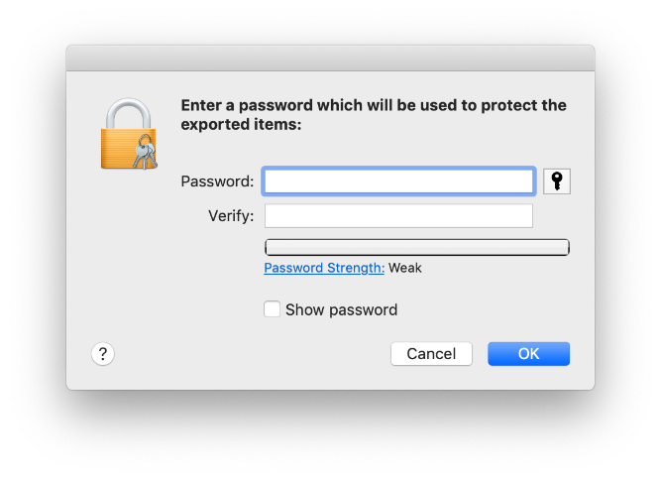

Step 5: Examine your application's Push Notifications code

The generated code will have all push notifications code in the AppDelegate.swift file. Open the AppDelegate.swift file to inspect the notifications code.

First, the device registers for remote notifications by calling the method registerForRemoteNotifications(:). Then, you have specified the types of notifications your app will support, as well as added a reference to the notification settings class, which enables your application for the push notifications to be received. This will result in your application to display the **“App Name” Would Like to Send You Notifications** confirmation dialog.

Let’s look at the initializeRemoteNotification(:) method. This method will take care of registering the app for receiving remote notifications and it will trigger the authorization request.

swift

Copy

func initializeRemoteNotification() {

// Registering for remote notifications

UIApplication.shared.registerForRemoteNotifications()

let center = UNUserNotificationCenter.current()

center.requestAuthorization(options: [.alert, .badge, .sound]) { _, _ in

// Enable or disable features based on authorization.

}

center.delegate = self

}

The uploadDeviceTokenForRemoteNotification(_:Data) will take care of uploading the app’s device token to the SAP Cloud Platform Mobile Services.

swift

Copy

func uploadDeviceTokenForRemoteNotification(_ deviceToken: Data) {

guard let session = sessionManager.onboardingSession else {

// Onboarding not yet performed

return

}

let parameters = SAPcpmsRemoteNotificationParameters(deviceType: "iOS")

session.registerDeviceToken(deviceToken: deviceToken, withParameters: parameters) { error in

if let error = error {

self.logger.error("Register DeviceToken failed", error: error)

return

}

self.logger.info("Register DeviceToken succeeded")

}

}

The next methods located under the **AppDelegate method implementations for remote notification handling** mark, are delegate methods for all remote notification handling.

swift

Copy

func application(_: UIApplication, didRegisterForRemoteNotificationsWithDeviceToken deviceToken: Data) {

self.uploadDeviceTokenForRemoteNotification(deviceToken)

}

func application(_: UIApplication, didFailToRegisterForRemoteNotificationsWithError error: Error) {

self.logger.error("Failed to register for Remote Notification", error: error)

}

// Called to let your app know which action was selected by the user for a given notification.

func userNotificationCenter(_: UNUserNotificationCenter, didReceive response: UNNotificationResponse, withCompletionHandler completionHandler: @escaping () -> Void) {

self.logger.info("App opened via user selecting notification: \(response.notification.request.content.body)")

// Here is where you want to take action to handle the notification, maybe navigate the user to a given screen.

completionHandler()

}

// Called when a notification is delivered to a foreground app.

func userNotificationCenter(_: UNUserNotificationCenter, willPresent notification: UNNotification, withCompletionHandler completionHandler: @escaping (UNNotificationPresentationOptions) -> Void) {

self.logger.info("Remote Notification arrived while app was in foreground: \(notification.request.content.body)")

// Currently we are presenting the notification alert as the application were in the background.

// If you have handled the notification and do not want to display an alert, call the completionHandler with empty options: completionHandler([])

completionHandler([.alert, .sound])

}

If you now run the app on your device, you will notice it will first ask permission to display notifications:

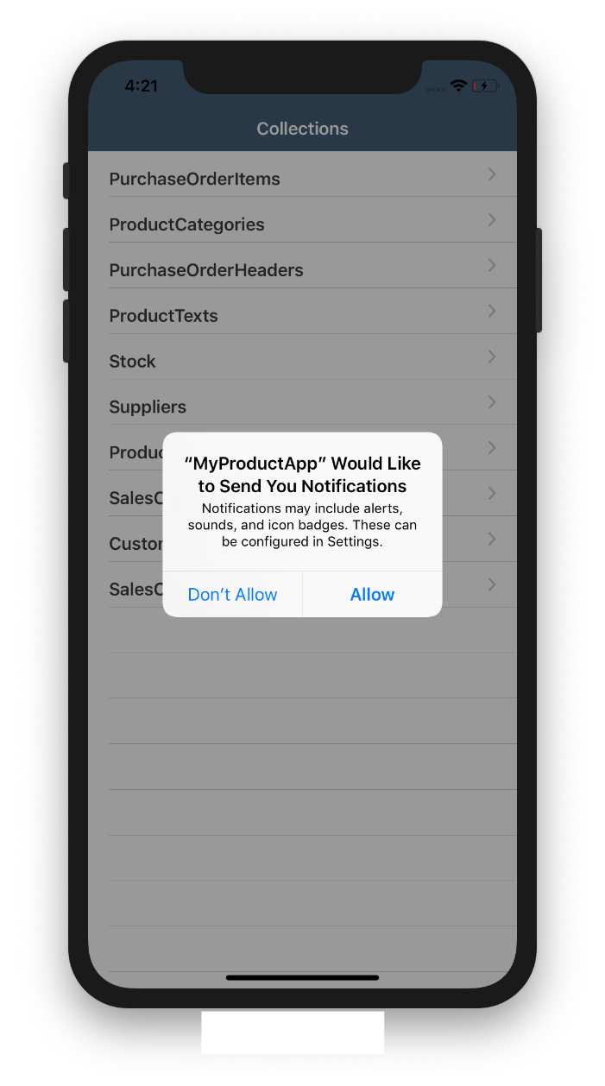

Screenshot Steps in SAP Cloud Platform –

